Hands-On Lab
Lab Manual
Build a simple App using CoreWa

Contents
Lab: Building a simple MVC App using CoreWa 3
Lab Objectives 3
Exercise – Create a simple application to add and list students. 4
1. Create a new Dynamic Web Project. 4
2. Import the necessary libraries into StudentDemoUsingCoreWa project. 5
3. Create XML files 5
4. Create DTO class(s). 6
5. Create DAO class(s). 8
6. Create CentralController and BaseForm files 10
7. Create control class(s): 14
8. Modify the web.xml file 18
9. Create JSP files 19
10. Refresh and then, run the project. 26
11. Righ-click on the project, select Run As > Run on Server. 26

Lab: Building a simple MVC App using CoreWa
Estimated time to complete this lab: 50 minutes.

Lab Objectives
This lab will guide you to building a simple MVC application using CoreWa:
Fisrt of all, take a view at resource of CoreWa in http://open-ones.googlecode.com/svn/trunk/CoreWa/SourceCode/CoreWa/.
- Log4j library to tracking your project’s flow.

References:
- Log4j: http://www.vipan.com/htdocs/log4jhelp.html

Exercise – Create a simple application to add and list students.

Create a new Dynamic Web Project.
- Goining to menu File > New > Dynamic Web Project. Input the values as following figure.

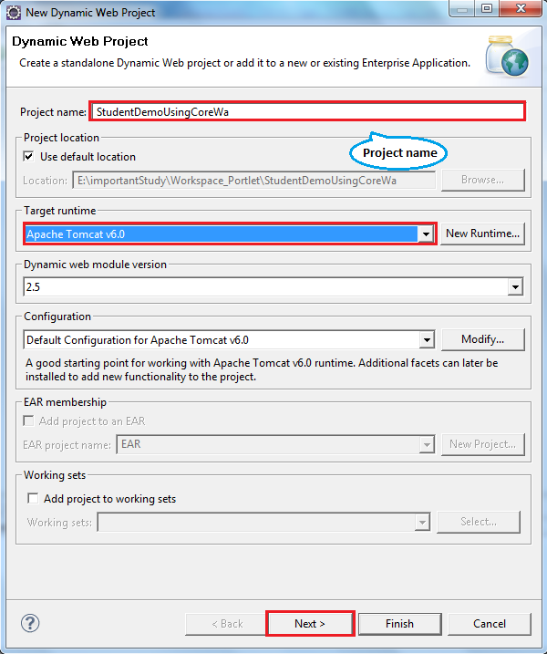

- In the next dialog, click Next button - >Finish.
- Click on Finish button. The structure of the project is:
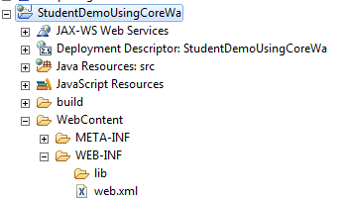

Import the necessary libraries into StudentDemoUsingCoreWa project.
- log4j-1.2.15.jar: this is used for log4j.
- corewa-conf-0.0.5-201104113083638.jar
- rocky-common-0.0.7-201104113103018.jar
- commons-collections-3.2.1.jar
- commons-fileupload-1.2.2.jar

Download these *.jar file and copy them to \WEB-INF\lib folder of StudentDemoUsingCoreWa project, then refresh project again.

Create XML files
- CoreWa using XML to define the main flow of application and handle the events
- Create main.xml file:

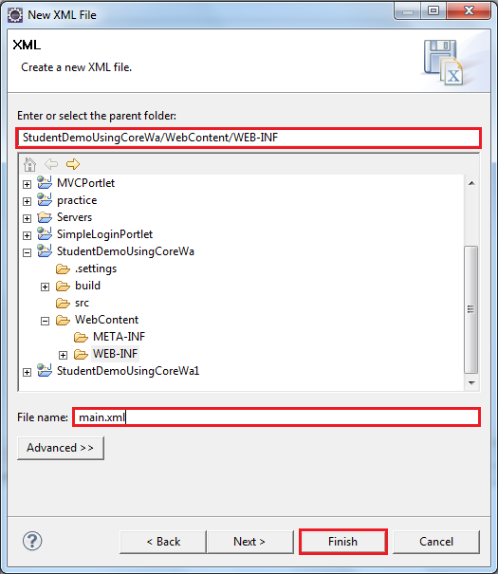

- Click Finish button
- Here is the main.xml file:

<?xml version="1.0" encoding="UTF-8"?>
<corewa>
<home-screen>Main</home-screen>

<screen id="Main" input="/WEB-INF/sample_layout_pages/main.jsp">
<event id="Menu" redirect="yes" nextScreen="/WEB-INF/sample_layout_pages/menu.jsp" />
</screen>

<screen id="Menu" control="openones.corewa.control.MenuControl" input="/WEB-INF/sample_layout_pages/menu.jsp">
<event id="Add" redirect="yes" nextScreen="/WEB-INF/sample_layout_pages/AddStudent.jsp" />
<event id="List" redirect="yes" nextScreen="/WEB-INF/sample_layout_pages/ViewStudents.jsp" />
</screen>

<screen id="Add" control="openones.corewa.control.AddStudentControl" input="/WEB-INF/sample_layout_pages/AddStudent.jsp">
<event id="Submit" redirect="yes" nextScreen="/WEB-INF/sample_layout_pages/AddStudent.jsp" />
<event id="Back" redirect="yes" nextScreen="/WEB-INF/sample_layout_pages/menu.jsp" />
</screen>

<screen id="List" input="/WEB-INF/sample_layout_pages/ViewStudents.jsp">
<event id="Back" redirect="yes" nextScreen="/WEB-INF/sample_layout_pages/menu.jsp" />
</screen>
</corewa>

- CoreWa using Screens, every Screen will have an Id, Controller, location of a .JSP file and some Events

Create DTO class(s).
- Create SimpleStudentDTO class in package openones.corewa.dto as following:

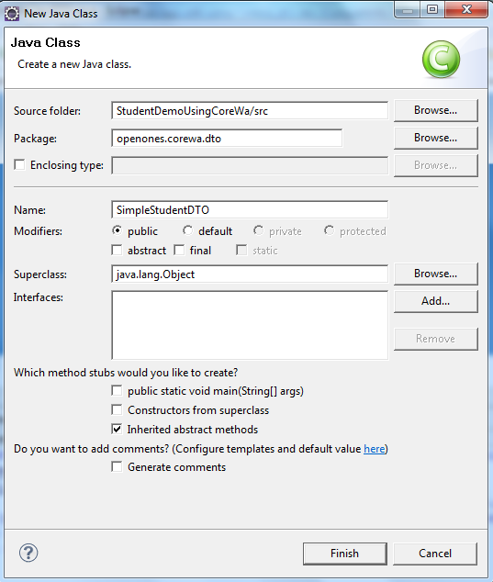

  - This class use to:
Represent the Student Object, it store the Student’s data

  - Content of this class:
public class SimpleStudentDTO {
private String id;
private String name;
private Date birthday;
private String avatar;
private float mark;
private String email;

public SimpleStudentDTO(){}

public SimpleStudentDTO(String id, String name, Date birthday,
String avatar, float mark, String email) {
this.id = id;
this.name = name;
this.birthday = birthday;
this.avatar = avatar;
this.mark = mark;
this.email = email;
}

public String getId() {
return id;
}

public void setId(String id) {
this.id = id;
}

public String getName() {
return name;
}

public void setName(String name) {
this.name = name;
}

public Date getBirthday() {
return birthday;
}

public void setBirthday(Date birthday) {
this.birthday = birthday;
}

public String getAvatar() {
return avatar;
}

public void setAvatar(String avatar) {
this.avatar = avatar;
}

public float getMark() {
return mark;
}

public void setMark(float mark) {
this.mark = mark;
}

public String getEmail() {
return email;
}

public void setEmail(String email) {
this.email = email;
}

}

Create DAO class(s).
- Create StudentDAO.java in package openones.corewa.dao as following
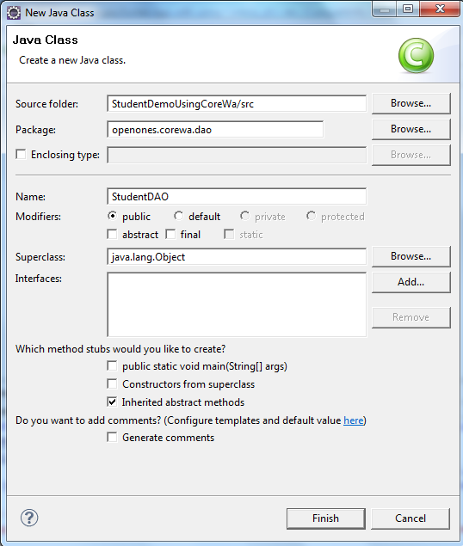

  - This class use to:
Object that access to the database and provides some methods for Student class

  - Content of this class:

public class StudentDAO {
public static List<SimpleStudentDTO> LIST_STUDENT = getAllStudent();

public static List<SimpleStudentDTO> getAllStudent(){
List<SimpleStudentDTO> list = new ArrayList<SimpleStudentDTO>();
GregorianCalendar calendar = new GregorianCalendar();
calendar.set(1989, Calendar.SEPTEMBER, 8);
SimpleStudentDTO student1 = new SimpleStudentDTO("07130028", "Lưu Thúy Hà", calendar.getTime(), "avatar.jpg", 9, "luuhait@gmail.com");
SimpleStudentDTO student2 = new SimpleStudentDTO("07130029", "Nhjm", calendar.getTime(), "avatar.jpg", 9.5f, "lth_sunflower@yahoo.com");
SimpleStudentDTO student3 = new SimpleStudentDTO("07130030", "HaLT", calendar.getTime(), "avatar.jpg", 8, "luuha@gmail.com");
list.add(student1);
list.add(student2);
list.add(student3);
return list;
}

public static boolean insertStudent(String id, String name, String birthday, float mark, String email, String avatar){
int day = 1, month = 1, year = 1989;
StringTokenizer tokenizer = new StringTokenizer(birthday, "-");
year = Integer.parseInt(tokenizer.nextToken());
month = Integer.parseInt(tokenizer.nextToken());
day = Integer.parseInt(tokenizer.nextToken());
GregorianCalendar calendar = new GregorianCalendar();
calendar.set(year, month - 1, day);
Date myBirth = calendar.getTime();

SimpleStudentDTO student = new SimpleStudentDTO(id, name, myBirth, avatar, mark, email);
LIST_STUDENT.add(student);
return true;
}

}

Create CentralController and BaseForm files
- Create CentralController.java file in package openones.corewa

@SuppressWarnings("serial")
public class CentralConntroller extends HttpServlet {
private final Logger LOG = Logger.getLogger(this.getClass().getName());
private final static String DEF_EVENTID = "init";
private final static String DEF_PROCID = "procInit";
private final static String DEF_ERRORPAGE = "/WEB-INF/pages/error.jsp";
private CoreWa conf;
private BaseOutForm resultForm;

static Map<String, Object> cacheControl = new HashMap<String, Object>();

@Override
public void init(ServletConfig config) throws ServletException {
super.init(config);
String confFile = config.getInitParameter("conf-file");
String realPath = config.getServletContext().getRealPath("WEB-INF/" + confFile);
LOG.log(Level.INFO, "real path of confFile=" + confFile);
try {
conf = ConfigUtil.parse(new FileInputStream(realPath));
} catch (FileNotFoundException fnfex) {
LOG.log(Level.CONFIG, "init", fnfex);
throw new ServletException(fnfex);
}
}
@Override
protected void doPost(HttpServletRequest req, HttpServletResponse resp) throws ServletException, IOException {
Screen screen;
Event event;
Object controlClass = null;
String procId = null;
String nextScrId = null;
Method method;

try {
req.setCharacterEncoding(Constant.DEF_ENCODE);
resp.setCharacterEncoding(Constant.DEF_ENCODE);

String screenId = req.getParameter("screenId");
String eventId = req.getParameter("eventId");
String servletPath = req.getServletPath().substring(1); // servlet path without forward character /
LOG.log(Level.INFO, "servlet path=" + servletPath);
LOG.log(Level.INFO, "home screen id=" + conf.getHomeScreenId());
if ((screenId == null) || (eventId == null)) {
eventId = DEF_EVENTID;
}
LOG.log(Level.INFO, "screenId=" + screenId + ";eventId=" + eventId);
screen = conf.getScreen(screenId);
if (screen == null) { // Using home screen from the configuration
screen = conf.getScreens().get(conf.getHomeScreenId());
}
event = screen.getEvent(eventId);
if (event != null) {
procId = event.getProcId();
nextScrId = event.getNextScrId();
}
if (!CommonUtil.isNNandNB(procId)) { // procId is not declared, it is default
procId = DEF_PROCID;
}
if (!CommonUtil.isNNandNB(nextScrId)) { // the next screen id is not declared, it is the same.
nextScrId = screen.getInputPage();
}
LOG.log(Level.INFO, "procId=" + procId + ";nextScreenId=" + nextScrId);
String ctrlClassName = screen.getCtrlClass();
if (CommonUtil.isNNandNB(ctrlClassName)) {
if (cacheControl.containsKey(ctrlClassName)) { // The control is already created
controlClass = cacheControl.get(ctrlClassName);
} else { // Create new the instance of the control. The put it into the cache
controlClass = Class.forName(ctrlClassName).newInstance();
cacheControl.put(ctrlClassName, controlClass);
}
}
// Assumption if tag <event> without attribute "redirect", tag "control" is not null
if ((event != null) && (!event.isRedirect())) {
// ScreenForm screenForm = (ScreenForm) BaseControl.getData(request, ScreenForm.class);
Map<String, Object> mapReq = BaseControl.getMapData(req);
LOG.log(Level.FINE, "Invoke method '" + procId + "' of class '" + screen.getCtrlClass() + "'");
try {
method = controlClass.getClass().getMethod(procId, HttpServletRequest.class, Map.class,
HttpServletResponse.class);
resultForm = (BaseOutForm) method.invoke(controlClass, req, mapReq, resp);
} catch (Exception ex) {
LOG.warning("Could not invoke method " + controlClass + "." + procId + "(Request, Map, Respone)");
// @deprecated
}

method = controlClass.getClass().getMethod(procId, HttpServletRequest.class, HttpServletResponse.class);
resultForm = (BaseOutForm) method.invoke(controlClass, req, resp);
}
} else if (controlClass != null) { // Initial screen
method = controlClass.getClass().getMethod(DEF_PROCID, HttpServletRequest.class, HttpServletResponse.class);
resultForm = (BaseOutForm) method.invoke(controlClass, req, resp);
Event.DispType distType = null;
if (resultForm != null) {
partResultFormIntoWeb(resultForm, req, req.getSession());
if (CommonUtil.isNNandNB(resultForm.getNextScreen())) {
nextScrId = resultForm.getNextScreen();
distType = resultForm.getDispType();
if (resultForm.isDispatched()) { // Skip next section if the request is dispatche in the control
return;
}
// resp.sendRedirect(resultForm.getNextScreen());
}
}
if ((resultForm == null) || (!CommonUtil.isNNandNB(resultForm.getNextScreen()))) {
if ((conf.getLayout() != null) && CommonUtil.isNNandNB(conf.getLayout().getId())) {
LOG.info("Layout page:" + conf.getScreen(conf.getHomeScreenId()).getInputPage());
nextScrId = conf.getScreen(conf.getHomeScreenId()).getInputPage();
}
if ((event != null) && (event.getDispType() == Event.DispType.FORWARD)) {
LOG.info("Forward to '" + nextScrId);
distType = Event.DispType.FORWARD;
} else {
LOG.info("Include '" + nextScrId);
distType = Event.DispType.INCLUDE;
}
}

LOG.info("nextScrId=" + nextScrId + ";distType");

// Process transition screen
RequestDispatcher dispatcher = req.getRequestDispatcher(nextScrId);

if (distType == Event.DispType.FORWARD) {
dispatcher.forward(req, resp);
} else if (distType == Event.DispType.INCLUDE) {
dispatcher.include(req, resp);
} else { // redirect
resp.sendRedirect(nextScrId);
}
} catch (Throwable th) {
LOG.log(Level.FINEST, "doPost", th);
th.printStackTrace();
req.getRequestDispatcher(DEF_ERRORPAGE).include(req, resp);
}
}

/**
*
* @param request
* @param session
*/
private void partResultFormIntoWeb(BaseOutForm resultForm, HttpServletRequest request, HttpSession session) {
//
if (resultForm != null) {
// Scan object in session map to put into the session
Map<String, Object> sessionMap = resultForm.getSessionMap();

if (sessionMap.keySet() != null) {
for (String key : sessionMap.keySet()) {
LOG.log(Level.FINEST, "Set session attribute: key = " + key);
session.setAttribute(key, sessionMap.get(key));
LOG.log(Level.FINEST, "Set session attribute: sessionMap.get(key) = " + sessionMap.get(key));
}
}

// Scan object in reqest map to put into the request
Map<String, Object> requestMap = resultForm.getRequestMap();
if (requestMap.keySet() != null) {
for (String key : requestMap.keySet()) {
LOG.log(Level.FINEST,"Set request attribute: key = " + key);
request.setAttribute(key, requestMap.get(key));
}
}
}
}

@Override
protected void doGet(HttpServletRequest req, HttpServletResponse resp) throws ServletException, IOException {
doPost(req, resp);
}

}

- Create BaseForm.java in package openones.corewa.form

@SuppressWarnings("serial")
public class BaseForm implements Serializable {
public BaseForm() {

}
}

Create control class(s):
In package openones.corewa.control:
- Create BaseControl.java

public class BaseControl {
final static Logger LOG = Logger.getLogger("BaseControl");

public BaseOutForm procInit(HttpServletRequest req, HttpServletResponse resp) throws ServletException, IOException {
LOG.log(Level.INFO, "procInit.START");
LOG.log(Level.INFO, "procInit.END");

return null;
}

/**
* Get data from web request to form bean.
* @param req
* @param clazz
* @return
*/
protected BaseForm getData(HttpServletRequest req, Class clazz) {
LOG.fine("getData.START");
Object bean = null;

try {
bean = clazz.newInstance();
// 1. Get all method setters
Map<String, Method> beanSetterMap = BeanUtil.getWriteMethodMap(bean);

// Scan all property
Object value;
Method method;
for (String propName : beanSetterMap.keySet()) {
// get value from the request basing property
value = req.getParameter(propName);
if (value == null) {
value = req.getAttribute(propName);
}
if (value != null) {
method = beanSetterMap.get(propName);
// Call method setter of property
LOG.fine("Set " + propName + "=" + value);
method.invoke(bean, value);
}
}
} catch (Exception ex) {
LOG.log(Level.FINE, "Get data form web request to form bean", ex);
}
LOG.fine("getData.END");

return (BaseForm) bean;
}
/**
* This method is invoked by CoreWa.
* @param req
* @return
*/
public static Map<String, Object> getMapData(HttpServletRequest req) {
Map<String, Object> result = new HashMap<String, Object>();
LOG.log(Level.FINEST, "getMapData.START:");
Object bean = null;

if (!ServletFileUpload.isMultipartContent(req)) { // Normal form data
String fieldName;
for (Enumeration<String> keyEnum = req.getParameterNames(); keyEnum.hasMoreElements();) {
fieldName = keyEnum.nextElement();
result.put(fieldName, req.getParameter(fieldName));
}
return result;
} else { // Upload form data
FileItemFactory fileItemFactory = new DiskFileItemFactory();
ServletFileUpload portletFU = new ServletFileUpload(fileItemFactory);
List items;
try {
items = portletFU.parseRequest(req);
FileItem fit;
String fieldName;
String value;
for (Iterator it = items.iterator(); it.hasNext();) {
fit = (FileItem) it.next();
fieldName = fit.getFieldName();

if (fit.isFormField()) { // Normal field
value = fit.getString();
result.put(fieldName, value);
} else {
result.put(fieldName, fit);
}
}
} catch (FileUploadException ex) {
LOG.log(Level.FINE, "Parsing the request", ex);
}

}
LOG.log(Level.FINEST, "getMapData.END");

return result;
}

}

- Create MenuControl.java
  - This class is the controller for the main menu (Add student and List students) of the application
  - Content of this class:

public class MenuControl extends BaseControl {

@Override
public BaseOutForm procInit(HttpServletRequest req, HttpServletResponse resp)
throws ServletException, IOException {
BaseOutForm outForm = new BaseOutForm();
if (req.getParameter("eventId").equals("Add")) {
outForm = new BaseOutForm();
} else if (req.getParameter("eventId").equals("List")) {
List<SimpleStudentDTO> listStudents = StudentDAO.LIST_STUDENT;
outForm = new BaseOutForm();
outForm.putRequest("students", listStudents);
} else {
return super.procInit(req, resp);
}
return outForm;
}
}

- Create AddStudentControl.java
  - This class is use to handle inserting new student
  - Content of this class:
public class AddStudentControl extends BaseControl {

@Override
public BaseOutForm procInit(HttpServletRequest req, HttpServletResponse resp)
throws ServletException, IOException {
req.setCharacterEncoding("UTF-8");
if (req.getParameter("eventId") != null && req.getParameter("eventId").equals("Submit")) {
BaseOutForm outForm = new BaseOutForm();
outForm = new BaseOutForm();

String studentId = req.getParameter("studentId");
String studentName = req.getParameter("studentName");
int day = Integer.parseInt(req.getParameter("day"));
int month = Integer.parseInt(req.getParameter("month"));
int year = Integer.parseInt(req.getParameter("year"));
String birthday = year + "-" + month + "-" + day;
String markStr = req.getParameter("mark");
float mark = 0;
String email = req.getParameter("email");
String avatar = req.getParameter("avatar");
if (avatar == null)
avatar = "";
String error = "";
if (studentId == null || studentId.equals(""))
error = "Please input Student Id";
else {
try {
mark = Float.parseFloat(markStr);
} catch (NumberFormatException e) {
error = "Mark must be a positive number";
}
}
if (! error.equals("")){
outForm.putRequest("error", error);
return outForm;
} else {
if (StudentDAO.insertStudent(studentId, studentName, birthday, mark, email, avatar))
outForm.putRequest("addResult", "Student has been added successfully !");
else
outForm.putRequest("error", "Student ID is already exist");
return outForm;
}
} else
return super.procInit(req, resp);
}
}

Modify the web.xml file

<?xml version="1.0" encoding="UTF-8"?>
<web-app xmlns:xsi="http://www.w3.org/2001/XMLSchema-instance"
xmlns="http://java.sun.com/xml/ns/javaee" xmlns:web="http://java.sun.com/xml/ns/javaee/web-app_2_5.xsd"
xsi:schemaLocation="http://java.sun.com/xml/ns/javaee http://java.sun.com/xml/ns/javaee/web-app_2_5.xsd"
id="WebApp_ID" version="2.5">
<display-name>StudentDemoUsingCoreWa</display-name>
<servlet>
<description> </description>
<display-name>MainControl</display-name>
<servlet-name>MainControl</servlet-name>
<servlet-class>openones.corewa.CentralConntroller</servlet-class>
<init-param>
<param-name>conf-file</param-name>
<param-value>main.xml</param-value>
</init-param>
</servlet>
<servlet-mapping>
<servlet-name>MainControl</servlet-name>
<url-pattern>*.do</url-pattern>
</servlet-mapping>

<welcome-file-list>
<welcome-file>index.jsp</welcome-file>
</welcome-file-list>
</web-app>

Create JSP files
- Create main.jsp file

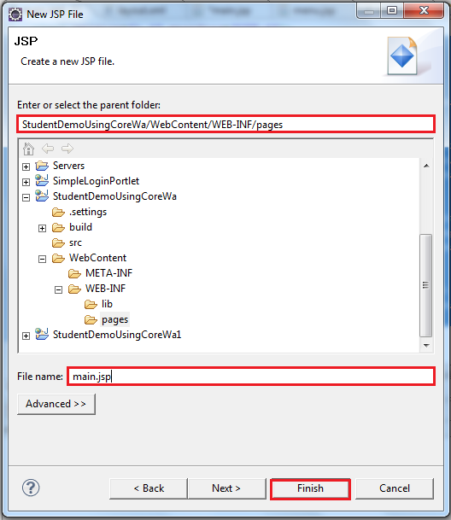

- Here is the content of main.jsp

<%@ page language="java" contentType="text/html; charset=UTF-8"
pageEncoding="UTF-8"%>
<!DOCTYPE html PUBLIC "-//W3C//DTD HTML 4.01 Transitional//EN" "http://www.w3.org/TR/html4/loose.dtd">
<html>
<head>
<meta http-equiv="Content-Type" content="text/html; charset=UTF-8">
<title>CoreWa demo</title>
</head>
<body>
<form name="MainForm" action="main.do">
Main page <input type="hidden" name="screenId" value="Main"> <input
type="hidden" name="eventId" value="Menu"> <input
type="submit" value="Manage Students">
</form>
</body>
</html>

- In this jsp, we create two buttons, Add Student button and View Students button, every button have a screenId and eventId. ScreenId is Id of the screen which we want forward to, eventId is Id of the event that we want to use in the Screen above

- Create menu.jsp file

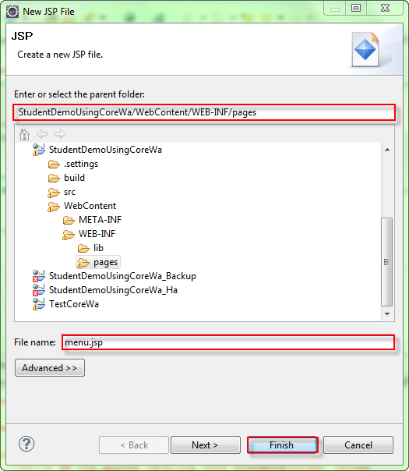

- Content of menu.jsp file

<%@ page language="java" contentType="text/html; charset=UTF-8"
pageEncoding="UTF-8"%>
<!DOCTYPE html PUBLIC "-//W3C//DTD HTML 4.01 Transitional//EN" "http://www.w3.org/TR/html4/loose.dtd">
<html>
<head>
<meta http-equiv="Content-Type" content="text/html; charset=UTF-8">
<title>CoreWa demo</title>
</head>

<body>
<form action="main.do">
<input type="hidden" name="screenId" value="Menu">
<input type="hidden" name="eventId" value="Add">
<input type="submit" value="Add Student">
</form>
<form action="main.do">
<input type="hidden" name="screenId" value="Menu">
<input type="hidden" name="eventId" value="List">
<input type="submit" value="View Students">
</form>
</body>
</html>

- Create AddStudent.jsp file

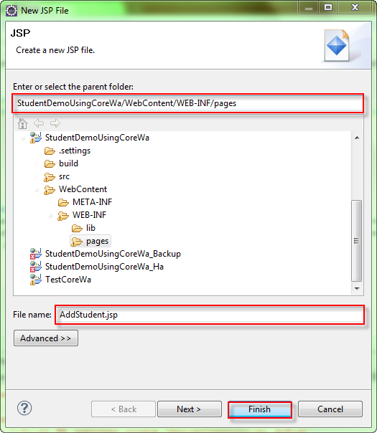

- Content of AddStudent.jsp file

<!DOCTYPE html PUBLIC "-//W3C//DTD HTML 4.01 Transitional//EN" "http://www.w3.org/TR/html4/loose.dtd">
<%@page contentType="text/html"%>
<%@page pageEncoding="UTF-8"%>
<html>
<head>
<meta http-equiv="Content-Type" content="text/html; charset=UTF-8">
<title>Add Student</title>
</head>
<body>
<%
String error = (String)request.getAttribute("error");
if (error == null)
error = "";
String addResult = (String)request.getAttribute("addResult");
if (addResult == null)
addResult = "";
%>
<script type="text/javascript">
function submitForm(frm, eventId) {
frm.eventId.value = eventId;
frm.submit();
}
</script>
<font color="red"><%= error %></font>
<%= addResult %>
<form id="addForm" action="main.do">
<table>
<tr><td>Student code:</td>
<td><input type="text" name="studentId"></td>
</tr>
<tr><td>Full name:</td>
<td><input type="text" name="studentName"></td>
</tr>
<tr><td>Birthday:</td>
<td><select name="day">
<% for (int i = 1; i <= 31; i ++) { %>
<option value=<%= i %>><%= i %></option>
<% } %>
</select>
<select name="month">
<% for (int i = 1; i <= 12; i ++) { %>
<option value=<%= i %>><%= i %></option>
<% } %>
</select>
<select name="year">
<% for (int i = 1945; i <= 2011; i ++) { %>
<option value=<%= i %>><%= i %></option>
<% } %>
</select>
</td>
</tr>
<tr><td>Mark:</td>
<td><input type="text" name="mark"></td>
</tr>
<tr><td>Email:</td>
<td><input type="text" name="email"></td>
</tr>
<tr><td>Avatar:</td>
<td><input type="file" name="avatar"></td>
</tr>
<tr><td></td>
<td><input type="hidden" name="screenId" value="Add" />
<input type="hidden" name="eventId" value="">
<input type="button" name="Submit" value="Submit" onclick="submitForm(document.getElementById('addForm'), 'Submit');">
<input type="button" name="Back" value="Back" onclick="submitForm(document.getElementById('addForm'), 'Back');">
</td>
</tr>
</table>
</form>
</body>
</html>
- Create ViewStudents.jsp file

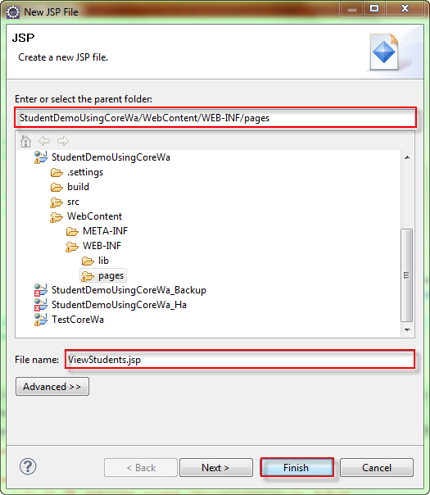

- Content of ViewStudents.jsp

<%@page import="java.util.GregorianCalendar"%>
<%@page import="java.util.Calendar"%>
<%@page import="openones.corewa.dao.StudentDAO"%>
<%@page import="openones.corewa.dto.SimpleStudentDTO"%>
<%@page contentType="text/html"%>
<%@page pageEncoding="UTF-8"%>

<!DOCTYPE html PUBLIC "-//W3C//DTD HTML 4.01 Transitional//EN" "http://www.w3.org/TR/html4/loose.dtd">
<html>
<head>
<meta http-equiv="Content-Type" content="text/html; charset=UTF-8">
<title>CoreWa demo</title>
</head>

<body>
<%
List<SimpleStudentDTO> students = (List<SimpleStudentDTO>)request.getAttribute("students");
%>

<%@page import="java.util.List"%>
<%@page import="java.util.ArrayList"%>

<table border="1" cellpadding="5">
<tr>
<th>ID</th>
<th>Name</th>
<th>Birthday</th>
<th>Mark</th>
<th>Email</th>
</tr>
<%
for (int i = 0; i < students.size(); i++) {
SimpleStudentDTO student = students.get(i);
Calendar calendar = new GregorianCalendar();
calendar.setTime(student.getBirthday());
String birthday = calendar.get(Calendar.DAY_OF_MONTH) + "/" + (calendar.get(Calendar.MONTH) + 1) + "/" + calendar.get(Calendar.YEAR);
%>
<tr>
<td><%= student.getId() %></td>
<td><%= student.getName() %></td>
<td><%= birthday %></td>
<td><%= student.getMark() %></td>
<td><%= student.getEmail() %></td>
</tr>
<% } %>
</table>

<form action="main.do">
<input type="hidden" name="screenId" value="List">
<input type="hidden" name="eventId" value="Back">
<input type="submit" value="Back">
</form>

</body>
</html>

- Create error.jsp file to handle errors

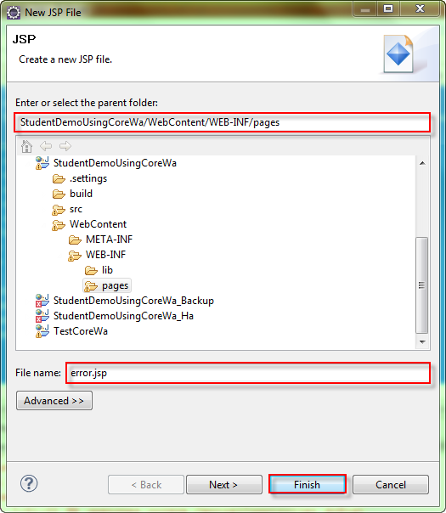

- Content of error.jsp file

<%@ page isErrorPage="true" %>
<% org.apache.log4j.Logger logger = org.apache.log4j.Logger.getLogger("Error"); %>
<html>
<head>
<title>Portal: An error has occured</title>
<meta http-equiv="Content-Type" content="text/html; charset=iso-8859-1">

<body>

<%
if (exception != null)
{
logger.error(exception.getMessage(), exception);
%>

<%-- Error message that user will see when an exception is thrown --%>
<p><strong>An error has occurred. Check the portal log for details.</strong>

<%
}
else
{
%>

<%-- Display text when page is loaded without an exception --%>
<p>You are looking at <code>error.jsp</code>. If an exception had been thrown
in one of the <code>.jsp</code> files, this page will be loaded and the stack trace
will be logged.

<%
}
%>
</body>
</html>

Refresh and then, run the project.

Righ-click on the project, select Run As > Run on Server.

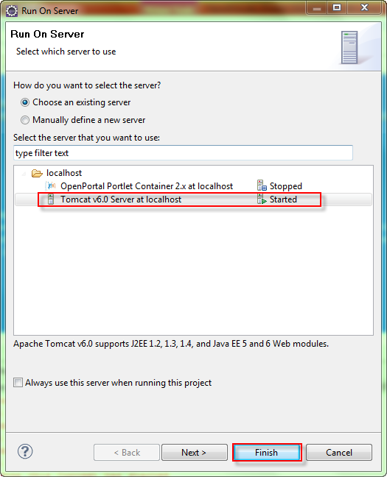

- If no available server exists, you have to add a new server to run project.

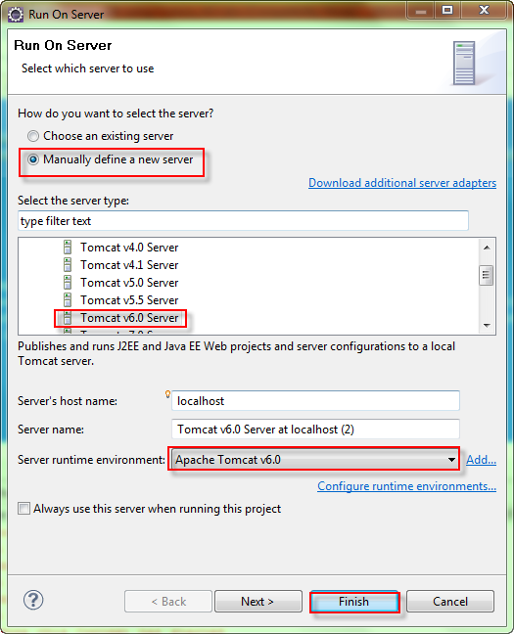

- And here is the result

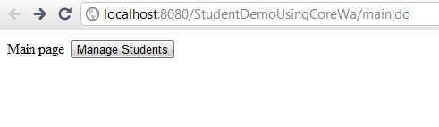
Main screen (main.jsp)

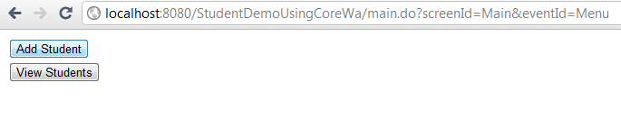
Main menu (menu.jsp)
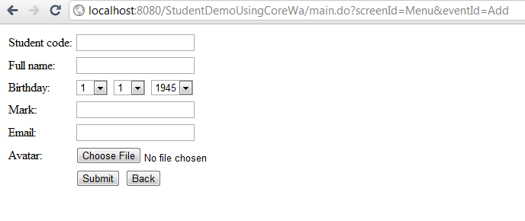
Add Student screen (AddStudent.jsp)

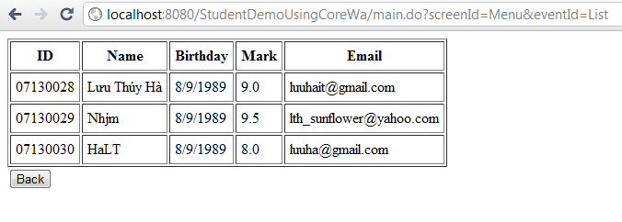
View Students screen (ViewStudents.jsp)

